How to setup the OPTICAL8SW_gamecontroller.

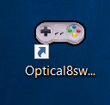

Step 1:

It founds automatic al the com ports in the pc.

Select the highest comport

Startup the program on your desktop after installation.

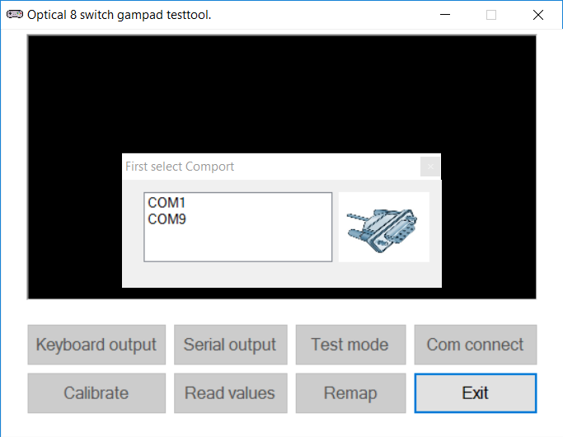

Step 2:

Click on Com connect button.

Step 3:

After a good connection the screen looks like this.

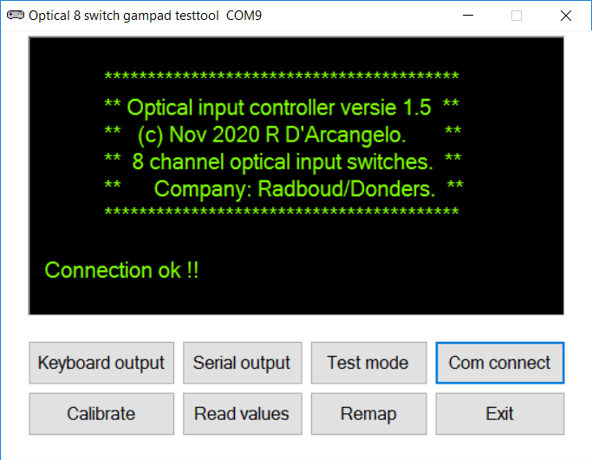

Step 4:

Click on the button **Calibrate** and follow the steps in the screen

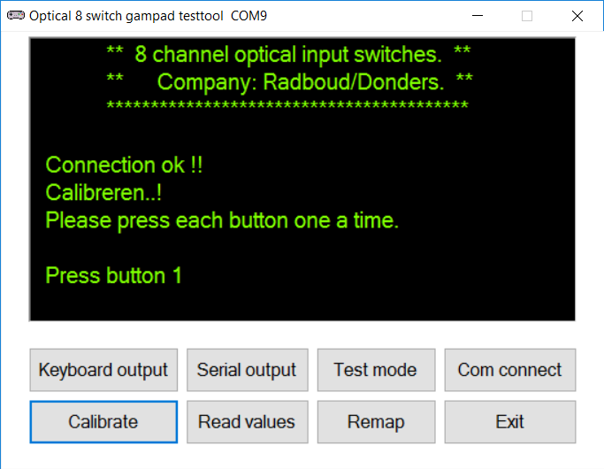

Step 5:

After calibration is finish the screen looks like this.

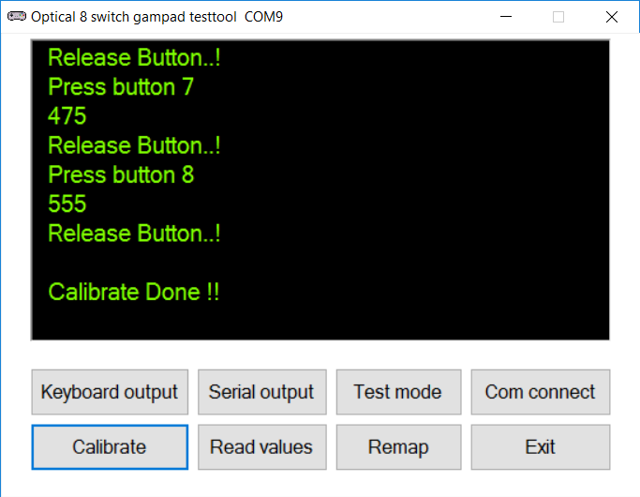

Step 7:

To test the output, press a button on the gamepad and the button in the screen lite up for each button.

Step 6:

After calibration is done, click on Keyboard output button.

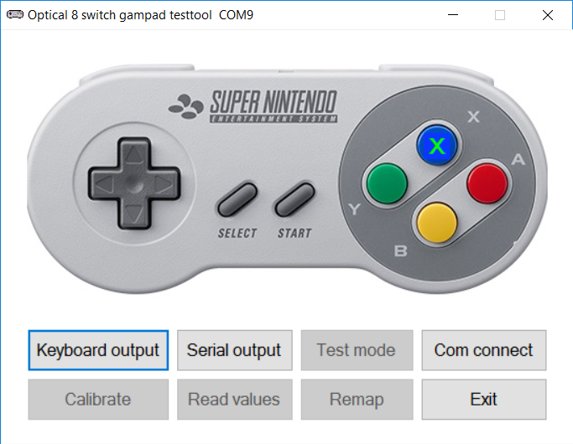

Step 8:

The gamepad is now ready and set as a keyboard HID for Windows.

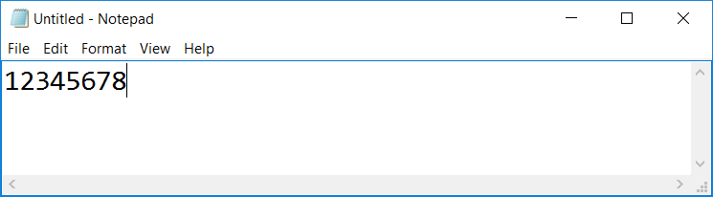

Extra options:

Shows the saved calibration values and the output char how are send to the PC

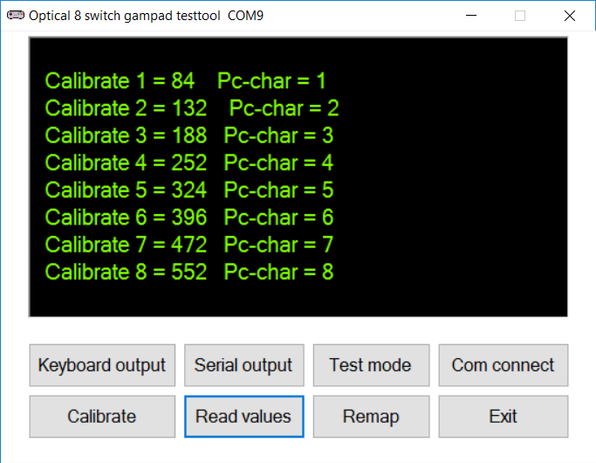

Extra options:

Shows in realtime the values from the gamepad serial to the pc.

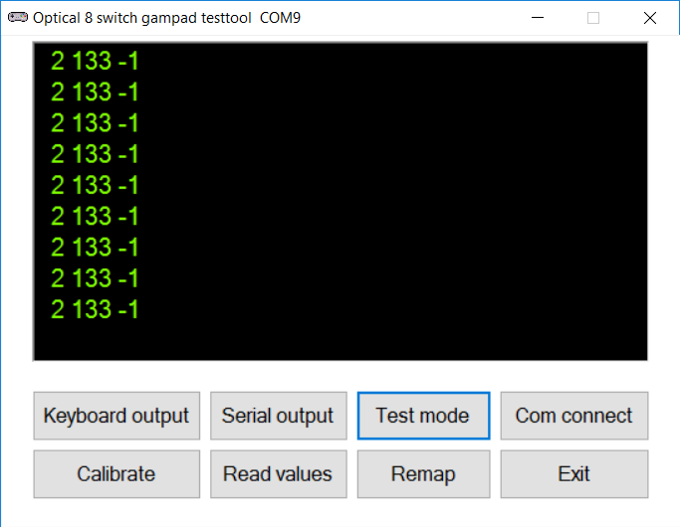

Extra options:

To remap the characters how are send to the pc.

Click this button to open the next screen.

Extra options:

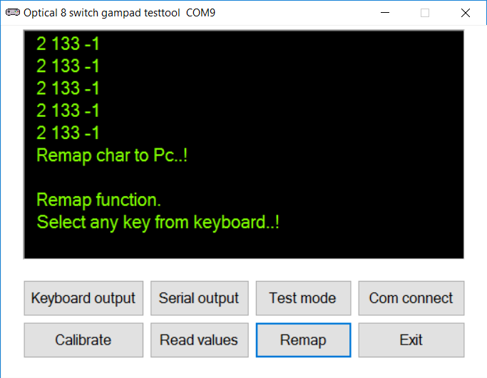

Extra options:

Choose others characters in the fields and click on Remap.

Default is always

1 ,2,3,4,5,6,7,8

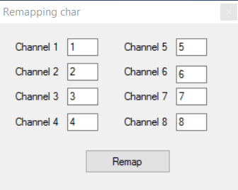

Al the values are stored in the EEprom and will not be lost if the power is disconnected.

When use putty,

Connect to serial port COM ……..(look in windows control panel).

Baudrate 115200

Press always H for the helpmenu.

